Name: jomol R.k
Roll No:9
Batch:s2 mca -B
Date:12/5/2022

NETWORKING & SYSTEM ADMINISTRATION LAB

Experiment No.: 21

Aim
write a shell script program to find sum of all digit in a number

Procedure
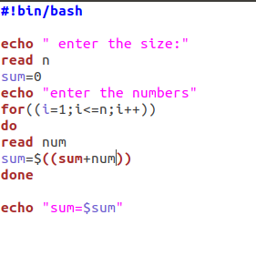

Output Screenshot
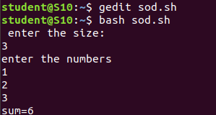

Experiment:22

Aim
write a shell script to find the average of the number entered in a command line
Procedure
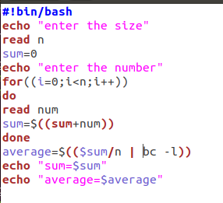

Output Screenshot
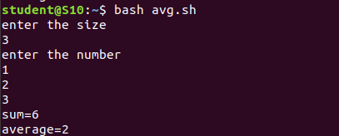

Experiment No.: 23
Aim
write a shell script arithmetic operations using switch case

Procedure
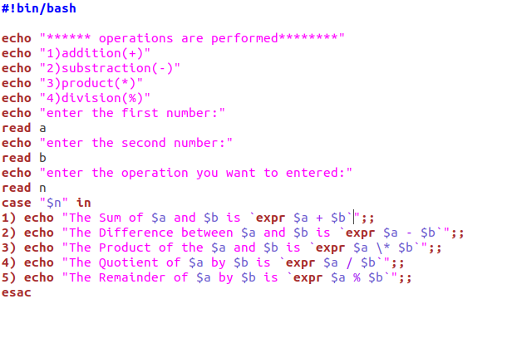

output Screenshot
